LESSON ONE
GETTING STARTED
INTRODUCTION

LESSON DESCRIPTION:
In this lesson, you will learn to identify terms commonly used in basic baton techniques. You will also learn the basic baton grip, how to stand, and what to do with your left hand.

LEARNING OBJECTIVE:

OBJECTIVE: At the end of this lesson, you will be able to identify terms commonly used in basic baton techniques. You will also be able to hold the baton correctly and present proper bearing and appearance in front of the ensemble.

CONDITIONS: Given the information in this lesson.

ACTIONS: You will:

1.Identify terms commonly used in basic baton techniques.

2.Demonstrate knowledge of the basic baton grip and the proper bearing and appearance required to lead an ensemble.

STANDARDS: IAW the material presented in this lesson.
LESSON ONE
GETTING STARTED
PART A VOCABULARY
1. You need to understand the following terms to take this subcourse.
a. Impulse of will Getting an ensemble to respond musically by effectively displaying confidence and leadership through body language and solid baton techniques. At any rehearsal certain amount of discussion is necessary between the conductor and the ensemble. As your baton techniques and your impulse of will improve, the need for discussion decreases.
b. Ictus The point at which the beat actually occurs. This is also called the beat point. It is normally defined by a slight flock of the wrist. The players must be able to see the ictus clearly.
c. Rebound/reflex/preparatory The part of the pattern that occurs between each ictus.
d. Active gesture A gesture that requires a musical response from the ensemble. In this subcourse, you will use the legato and staccato gestures.
e. Passive gesture A gesture that does not require a musical response from the ensemble. the preparatory gesture, also called the preparatory beat, is classified as a passive gesture.
f. Meter The recurring pattern of accented and unaccented pulsations.
g. Metrical stress The beat groupings within the meter. If the meter establishes beat groupings of two, three, or four; the metrical stress is duple, triple, or quadruple respectively. Metrical stress also describes the division of the beat into either simple or compound meter.
h. Simple and compound meter In most music, the unit of beat is regularly divisible by two or three. When the unit of beat is divisible by two, the meter is simple. When the unit of beat is divisible by three, the meter is compound.
NOTE: For a more complete explanations of meter-related terms, see TC 12-41, Basic Music, Chapter Three.
i. Divided beat The normal division of the unit of beat. When a beat is divided into two equal parts in simple meter or three equal parts in compound meter, it is a divided beat (Figure 1-1).
Figure 1-1: Divided Beat.
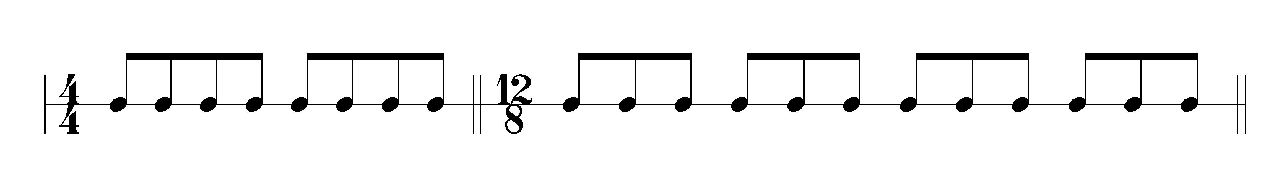
j. Subdivided beat When the divided beat is further divided, it is known as the subdivided beat or as subdivision (figure 1-2).
Figure 1-2: Subdivided Beat.
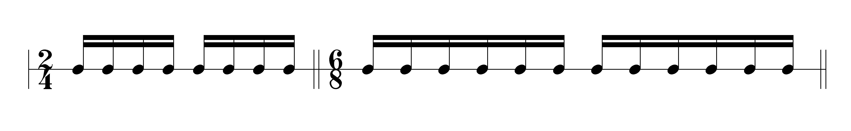
k. Conducting window An imaginary rectangle is in front of your body that sets the size of your beat pattern.
PART B BASICS
2. Bearing/Appearance. Your appearance, bearing and behavior in front of the ensemble are important. Show poise, dignity, and sincerity. This does not mean being cold and humorless. Proper military bearing and appearance, combined with good leadership and technical skills, will produce an effective rehearsal and a good performance.
3 Baton Grip. Good baton techniques begin with a proper baton grip. A proper baton grip helps you to keep your wrist flexible. It will also make it easier to control the tip of the baton. You will feel less fatigue on the arm when a proper baton grip is used. To obtain a proper grip, follow these steps.
a. Grip the baton in you right hand.
NOTE: Grip the baton in your right hand, even if you are left handed. Players are accustomed to seeing baton movements with the baton in the right hand.
b. Rest the heel of the baton in the center of your palm (figure 1-3).
Figure 1-3: Heel of the Baton Position.
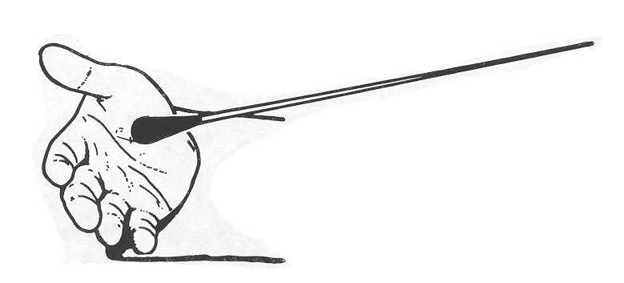
c. Keep the heel of the baton in contact with your palm. Grasp the baton between the tip of your thumb and side of your index finger. The baton will contact the side of your index finger somewhere between the middle joint and nail (Figure 1-4). The exact place depends on the size and shape of your fingers and hand. This position helps relax your wrist.
Figure 1-4: Thumb and Index Finger Position.
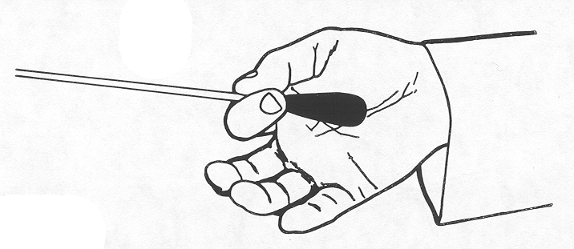
NOTE: Be careful not to clamp your thumb and index finger together too tightly. If you grasp the baton tightly, you will constrict your wrist muscles. This will cause your arm to tire quickly.
d. Curl your middle, ring, and little fingers inward. Keep these fingers relaxed and curled naturally. If you stiffen them especially your little finger, it will detract from the clarity of your baton techniques (Figure 1-5). If you curl them tightly into a fist, you will constrict your wrist and forearm muscles. This will make your arm tire quickly.
Figure 1-5: Middle, Ring, and Little Finger Positions.
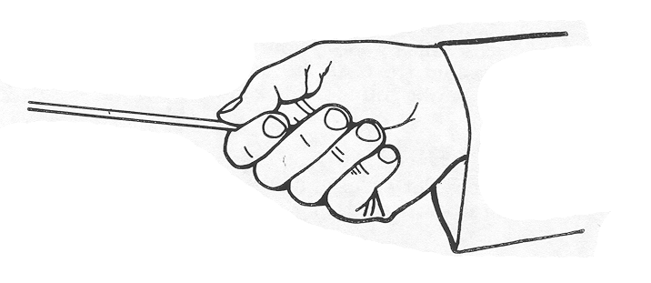
e. Turn the palm of your hand toward the floor. Your palm generally faces the floor when you perform beat patterns. The natural up and down motion of the wrist is defeated if your palm faces up or too far to the left. Point the tip of the baton forward. The players on your right cannot see your beat patterns if you point the tip of the baton to your left (figure 1-6).
Figure 1-6: Palm Position.
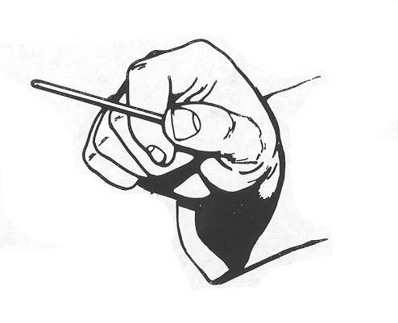
4. Baton Selection. In general, use a baton that is about 12 to 14 inches in length. It should be composed of a lightweight material and feel balanced when gripped properly. The heel of the baton should feel comfortable to you and allow you to grip the shaft between your thumb and index finger. Select a baton that is as white as possible so it will not blend with background colors.
NOTE: For good visibility, use a longer baton to conduct an ensemble that is standing.
5. Conducting Stance.
a. Formal Stance. When ceremonial music is being rehearsed or performed, stand at the position of attention (Figure 1-7).
Figure 1-7: Formal Stance.
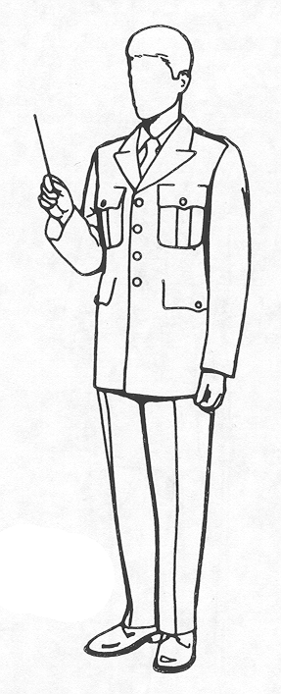
NOTE: Your left hand may be either at your side or held horizontally at your waist.
b. Informal Stance. When you are rehearsing or performing music other than ceremonial, you may use a less formal stance. Stand with your feet slightly apart, while maintaining proper bearing and appearance. An informal stance provides you more freedom of moment and a better ability to express yourself musically (figure 1-8).
Figure 1-8: Informal Stance.
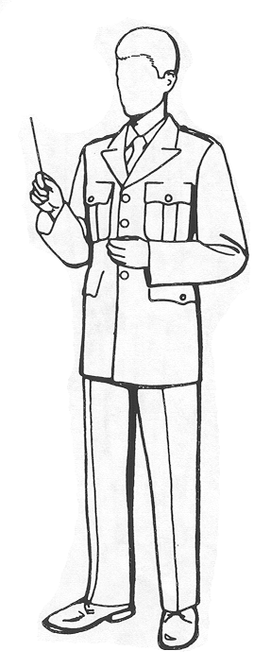
NOTE: Your left hand may be either at your side or held horizontally at your waist.
6. Conducting Windows.
a. A large window is appropriate for learning baton techniques and for loud dynamics (Figure 1-9).
Figure 1-9: Large Conducting Window.
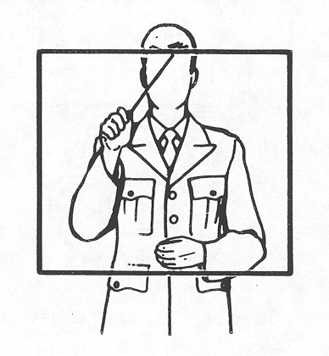
b. A smaller window is appropriate for softer dynamics and quicker tempi (Figure 1-10).
Figure 1-10: Small Conducting Window.

c. If the ensemble is standing, move your conducting window above should height. This will make your beat pattern more visible to the players (Figure 1-11).
Figure 1-11: Conducting Window Above Shoulder Height.
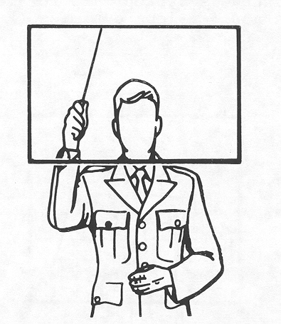
7. Baton Movements. The way you move the baton will convey your instructions to the players. You must transfer your intentions to the tip of the baton in order for the ensemble to respond correctly. To do this, keep the following things in mind.
a. Think of the baton as an extension of your hand. Keep your wrist flexible and maintain a proper baton grip.
b. Use your wrist and elbow joints to move the baton. Use little shoulder motion. Your elbow should be close to, but not touching, your body.
c. Do not allow the heel of the baton to slip under your little finger. This will cause the tip of the baton to point to the left, which handicaps the players to your right.
d. Allow yourself to make minor adjustments in your baton grip as you become more experienced. Strive for a grip that feels natural to you and keeps your movements clear and readable to the players.

